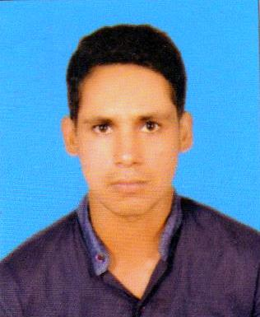

House no.45/c bhangel, near noida secor 18, metro station (201304)

**CAREER OBJECTIVE**

seeking a job that utilize my career knowledge skills & explore new avenue in social world

**PROFESSION-**

CIVIL ENGINEER

**EMPLOYMENT RECORD-**

**Quality Buildcon Pvt. Ltd. (JUNE 2014 JUlY 2016)**

**( 2.1year)**

PROJECT NAME- Hundred bedded colony at tilaknagar

(NEW Delhi )

CLIENTNAME - Municipal Corporation of Delhi

PROJECT COST - 48 Cr.

JOB ROLE - Site Engineer

**EMPLOYMENT RECORD-**

**ACE PARKWAY - (NOVEMBER 2016 to DECEMBER2018 )**

**(2.1 year)**

PROJECT NAME - Propsed group housing (ACE PARKWAY)

At: plot no.sc-01/B-8 Sector 150, Greater noida

**TOWER-2 ,2B+G+25=28**

CLIENT NAME –ACE GROUP(

PROJECT COST- 135 Cr

**JOB RESPONSBILITY**-

* Knowledge of all Building works from structural to finishing works ** plumbing works CI and GI
* Review of structural,architectural and plumbing,
* Planning for execution of work.
* Maintaining DPR and reporting to project manager.
* Well versed in handling AUTO LEVEL

**KEY RESPONSIBILITY**

Knowledge of Billing (BOQ) items.

Coordinate technical aspects of project supervise site and report progress to senior.

Conducting daily meeting with our clients for reviewing the work of the day and plan for next day.

**EDUCATION**

**B.E (CIVIL)-** **2014** From Annamalai university( Tamilnadu)-(70 %)

**12th**–**2009** From Rashtriya intercollege mau (u.p)-( 61.2% )

**10nth-2007** janta inter college nandawan (Azamgarh)(u.p)-( 62.5%)

**ADDRESS**

**CONTACT**

**CIVIL SOFTWARE SKILL**

**Auto Cad** 2D & 3D

**STAAD Pro**–Modelling detailing Foundation,Concrete ,steel design

**REVIT** Architecture

**COMPUTER SKILL**

Microsoft Excel

Microsoft Office

**Email**- shahidanwar5410@gmail.com

**Phone no.** 8920354945

DATE - 25-12-2018 MD. SHAHID

PLACE - NEW DELHI

**Declaration**

I hereby declare that the details furnished above are true to the best of my knowledge.

**AREA OF INTEREST**

BUILDING CONSTRUCTION

HIGHWAY ,BRIDGE

**PERSONAL PROFILE**

Name MD. SHAHID

DOB 20/07/1992

Gender Male

Marital Status Un Married

Nationality Indian

Language Hindi - English

Permanent Add Bakkabad, chiraiyakot

DISTT - Mau ( U.P )

PIN CODE - 276129